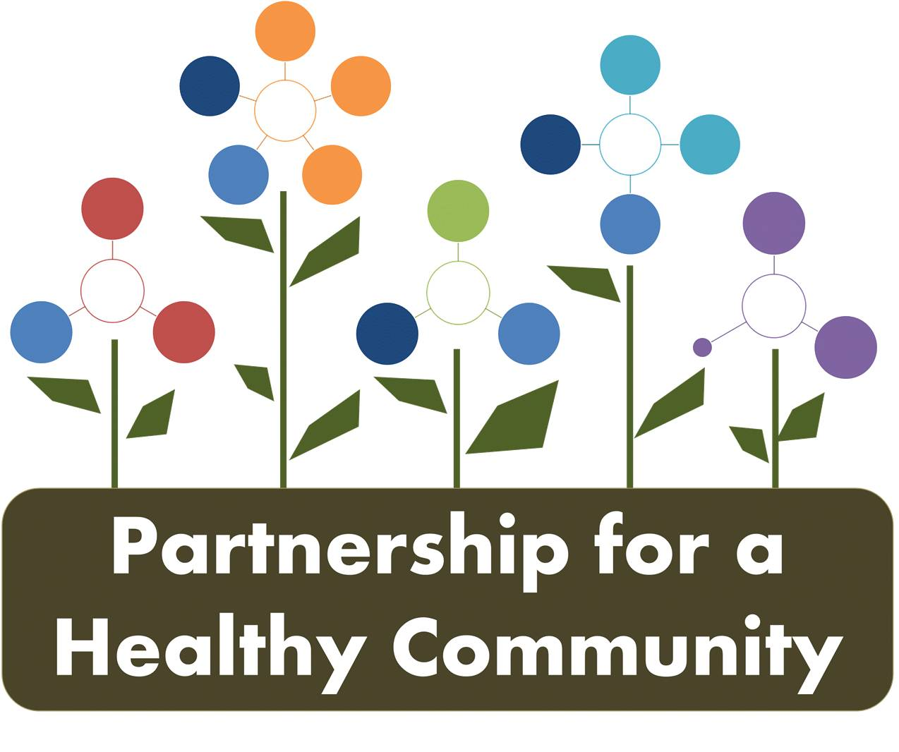
Breast Cancer Sub-Committee Meeting
Tazewell County Health Department
May 8, 2018 1:00-2:45
Attendees: Kim Gudzinskas (TCHD), Julie Herzog (TCHD), Donna Long (UPHM), Diana Scott (PCCHD), Andrea Ingwersen (WCHD), Kim Litwiller (TCHD), Beth Scheuermann (TCHD), Michelle Hobbs (TCHD), Greg Eberle (Hopedale Medical Complex)

-The group discussed the March meeting and there were no changes or additions to meeting minutes.
-Greg informed the group that he spoke to Cindy Martin, Director of Women’s Services at OSF, and OSF will require an MOU or some other form of legal document to share data with the Partnership for a Healthy Community. The Partnership board will be working on this with all the committees and hospitals, a blanket agreement to share data across all the priorities/committees moving forward. So, in the near future, the committee cannot expect any more data from OSF until there is a legal document in place.
-Greg discussed his experience attending Public Health 3.0 from the perspective of a hospital; an eye-opening, positive experience in which he learned a lot about treating the health of the population/community from the prevention perspective. He discussed with the group about bridging the gap between hospitals and public health to not only treat or prevent disease but looking at other factors like environment and behaviors.
-Dashboard updates for both lung and breast cancer groups: Greg and Ev, as co-chairs, discussed keeping both groups on the same page as far as how group work will documented.
- Meeting minutes will still be kept and sent to all members after each meeting as a reference
- The “paper” dashboards will still be updated in current form; Diana volunteered to update the dashboards from meeting minutes and label them accordingly with updated dates
- May create google docs for dashboards and other group work; still need to decide administration of that, who implements and manages? Also, how does that work with the new Partnership website?
-Discussion ensued about tracking progress and that the group doesn’t want to lose any notes, or indicators, and what the purpose of having a dashboard was. That “who” (individual or agency) is working towards strategies, not just sharing information.
-The group needs to “move the dial” and data direction, how things are reported, and flow of reporting needs to be decided. Greg will bring this up to the Partnership board; to get direction on data sharing and reporting with implementation of new website, etc.
-Discussion about the future of the group, that collective work need to be impactful to community and clients. Kim G. stated that IBCCP needs community partners/collaborative group to assist with outreach
-The group discussed what community partners are missing from this collaborative group:
- Unity Point-Pekin
- Illinois Cancer Care
- Community representation-breast cancer survivors
- Higher education groups-sororities and other student groups
- Faith community-Ministerial Alliances, Diocese, parish nurse groups
-A goal in the near future would to create canned messaging to assist with outreach, and to address gaps. What exactly are the current “gaps” will also be address at a future meeting.
-the current Partnership Cancer-Breast dashboard was reviewed by task and discussion was as follows:
Follow-up items and Kim G’s. “homework” tasks she assigned to the group are highlighted in yellow.
1. What exactly is our baseline? Cannot keep waiting on hospitals to report 2018 data, so will work with 2017 as the baseline, which is OSF and Unity Point. 36, 815 screenings for 2017 (see attached chart) and changing age range to 40-69. Diana will add available screening numbers to dashboard quarterly and change indicators.
1b. ACS has changed to 50, OSF and Komen, IBCCP and American College of Radiology recommend first screening at 40. Group decided to officially change age range to track screenings and recommendation to 40-69.
1c. Can we make a recommendation as a collaborative group? A declaration that the collective group as the Partnership recommends women start screenings at age 40? Can Komen push that recommendation out to providers? ***This is “homework” for the next meeting, the group will discuss further individual thoughts
1d. completed
1e. Need to decide what are our key events? IBCCP did in-service training with all staff at each Heartland site. Other outreach key events discussed: Central Illinois Black Expo, Peoria Black Chamber, and Women’s Lifestyle Show
***Another “homework” task, gather information about other key events for outreach that don’t cost a lot of $
Reporting quarters are as follows for collecting outreach numbers at events:
Jan-March: Quarter 1 April-June: Quarter 2
July-September: Quarter 3
October-December: Quarter 4
1f. Discussed culturally adapted outreach (see above for key events for outreach) not just being race/ethnic based but also religion. Kim Litwiller (TCHD) is a Mennonite pastor and will look into this further for the group. ***Friendship house has a Hispanic outreach program? Peoria based Hispanic/Latin groups?
-IBCCP has bilingual outreach materials
1g. IBCCP working on this. Kim G. gave a program summary; assigned caseload through grant year ending June 30th: 358, includes Komen #’s 40-49.
-individuals can be counted for caseload numbers if entered in Cornerstone, currently Kim G. is the only one that can enter and she is currently working on January 2018.
-need more from Woodford and Marshall counties
1h. discussed definition of medical home. Is IBCCP listed as a provider in 211? Follow-up to see if 211 has mammogram providers listed?
-Julie Herzog received a report form 211 for referrals for AOK Network and has contact. The group can also promote canned message when it is created. Julie will give Andrea contact and she will review to see if IBCCP, other mammogram providers are listed.
***Follow-up: On 211 website, 211hoi.org, under “health care” and then search “mammograms” Heartland Health Services is the first listing, TCHD-IBCCP is the second listing, then TCHD, WCHD, then Marshall, Bureau & Putnam, Henry & Stark HDs. There is a “add your agency” tab on the 211 website.
2. Change age range to 69; target women who have never had a mammogram, “1st timers.” Can start collecting this data for 2018 and use as baseline.
2b. Discussed guidelines for referrals, based on family history usually. Need further discussion. My notes were a little fussy on this one!
2c. Greg is checking with Hopedale and Eureka hospitals; OSF and Unity Point already doing.
3. OSF and Unity Point have navigator programs; Hopedale and Eureka refer, so this task is complete, there is already a system in place.
4. Greg is collecting data.

Next meeting:
- June 19th 2:00-3:30 Quarterly meeting for both Breast and Lung Cancer groups at Woodford County Health Department
- July 10th 1:00-2:30 Breast Cancer at Woodford County Health Department

