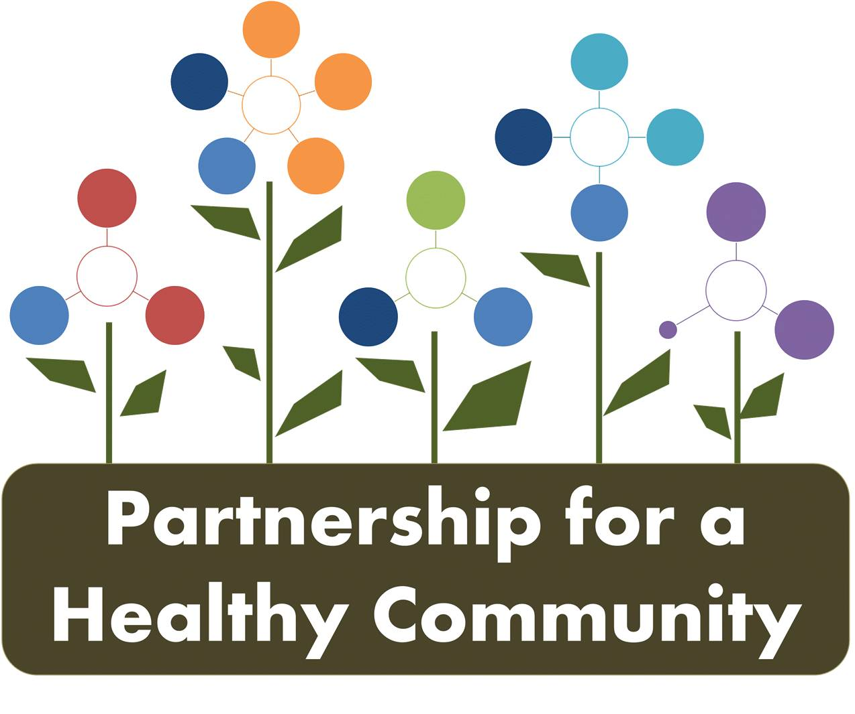
Breast Cancer Committee Meeting
Peoria City/County Health Department
August 14, 2018
1:00-2:30
In attendance:

Andrea Ingwersen, Woodford County Health Department
Diana Scott-Peoria City/County Health Department
Donna Long-Unity Point Health Methodist
Gayle Young-Susan G. Komen
Julie Herzog- Tazewell County Health Department
Michelle Hobbs-Tazewell County Health Department
Maria Salzman-Tazewell County Health Department
Michele Sharping-Tazewell County Health Department
Diane Hann-CRC Life

Nikki Willenborg-OSF (call in)
Wendy Lewis-CRC Life (call in)
Kari Gattung-Advocate Eureka (call in)

Minutes:

Andrea Ingwersen facilitated the meeting as Greg Eberle, Co-chair, (Hopedale Wellness) was unable to attend but emailed notes to be shared with the group.
The group reviewed the updated dashboard-each time the dashboards are updated, the date will be on bottom- right of the document.
Gather information for key event outreach $0
- Woodford County Libraries: Andrea
- Circle of Promise Peoria (3/16/19): Michelle (TCHD)- African American minority
  - Virginia Pearl
  - Riverside Church
  - Creekwood
  - Logan Park Bicycle Event- Ride for Safety
- IBCCP: Michele S.-TCHD
  - 5 outreach events in the community coming up.
2-1-1 Search Mammogram -> Health Department IBCCP/Hospitals
Finalized ages: 40-69 guidelines
MOU- Greg spoke with HOI partnership Board. Being developed by the Board. Making very general across the board to fit all needs of all Healthy HOI groups.
Proclamation document: Needs to be approved by the Board
- Who we are and what we represent
- Guidelines and recommendations
Komen’s stand: any woman over the age of 40 to have discussion with doctor without barriers
- Hospitals: Statement??
- Develop for Breast Cancer Awareness Month (October)
  - Andrea/Diana-PIO
  - Individual Agency Social media & HOI website
- Rough Draft -> Cancer Group -> HOI Board

- October 19, 2018 is National Mammogram Day
  - Point person??
  - Komen will put out outreach information.
- Follow-up Outreach:
  - Andrea: Roanoke Apostolic Church
  - Kim Litwiller-TCHD, also Mennonite pastor (Michele will follow-up with Kim)
  - Need to Identify Rural Communities
    - Food Pantries
    - School Districts (PTA/Teachers)
    - Dollar Generals
- Michele: Get current FY19 participants in IBCCP
  - FY18 served participants
- 2-1-1 Update (completed)
  - Target increase 10%- still collecting data
  - Baseline: Eureka 2017-2018 will provide
  - Identifying patients who are at-risk (OSF/UP)
    - MQSA: at-risk screening at facility at time of mammogram
  - Navigator Programs: OSF/UP completed
  - Mortality Rates: State Cancer Registry
    - Greg collecting data
Next Meeting-
Quarterly Meeting: Breast and Lung-September 18-Peoria Peoria City/County HD 2-330pm
Breast Cancer Meeting- October 9- Tazewell County HD 1-230pm
Lung Cancer Meeting- October 10- Peoria City/County HD 2-330pm

