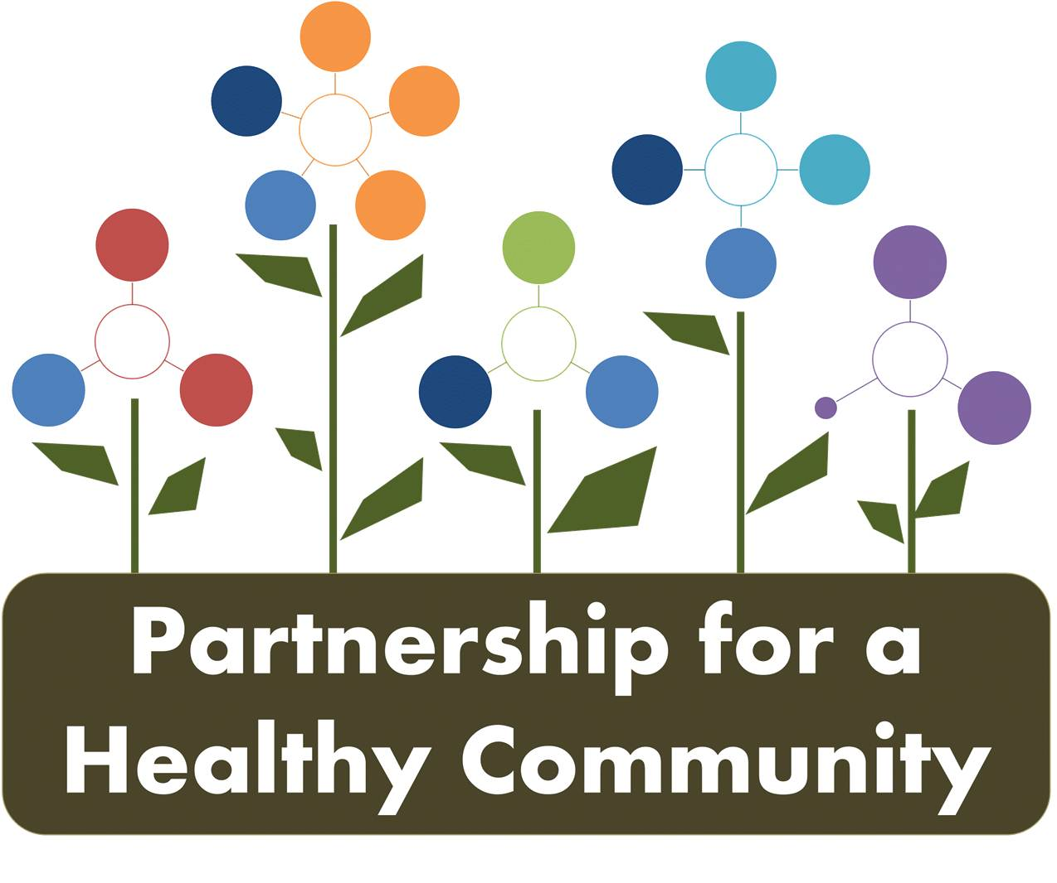
Breast and Lung Cancer Committees-Quarterly Meeting
Tuesday December 18, 2018 2:00-3:30 PM
Tazewell County Health Department
In Attendance:
Greg Eberle-Breast Cancer Sub-Committee Chair, Hopedale Wellness Center/Medical Complex
Ev Neavear-Lung Cancer Sub-Committee Chair, Tazewell County Health Department

Grant Allen-211 Resource Specialist
Julie Angle, Tazewell County Health Department
Melissa Goetze, Tazewell County Health Department
Diane Hahn, CRC Life
Diana Scott, Peoria City/County Health Department
Michele Sharping, Tazewell County Health Department
Kim Gudzinskas, Tazewell County Health Department
Julie Herzog, Tazewell County Health Department
Donna Long, Unity Point
Jessica Johnson, Hult Center for Health Living
Andrea Ingwersen, Woodford County Health Department
Nathaniel Johnson-UnityPoint
Katie Traenkenschuh-Tazewell County Health Department
Hannah Wang-University of IL. College of Medicine

Phone in: Kari Gattung-Advocate Eureka Hospital

Grant Allen, 211 Resource Specialist presented to the group about 211. 211 is funded by the United Way, in other states, 211 has state funding, not the case in Illinois. 211 covers six counties: Peoria, Tazewell, Woodford, Marshall, Putnam and Stark. There are 2 Full time employees.

-211 works as a community resource guide and also works with the Continuum of Care to provide assessments for chronically homeless; there is someone on-call for assessments for homeless 24/7.

-Word is still getting out about 211, some carriers still don’t route to 211. Grant asked that everyone add 211 to their agency website or promote as a resource. 211 promotional cards are available at United Way offices in Peoria.

-Still finding gaps in 211, especially in general myths about what is available, and the reality of channeling services. Not every service is available all the time ex: deadlines for help with electricity/heating bills.

-211 wants suggestions on how services are listed; wants people to tell them about errors so they can be as accurate as possible.

-Gina Edwards is in charge of marketing for United Way and 211.

Breast Cancer Committee:

-Reviewed the breast cancer position statement, made changes for 4th draft. The committee would like to present the position statement at the Annual meeting and then the group will make a plan for distribution.

BC dashboard review:

-1e: each quarter is listed, complete

-2b: Hopedale and Advocate asks questions and if a patient is “at risk,” patient is referred

-2c: All doctors ask basic screening questions because they see patients before age 40

-4: Komen provided baseline, please provide 4th quarter screening numbers to Greg for dashboard and report updates

Lung Cancer Committee:

LC Dashbaord review:

Tobacco and Radon dashboards are pretty much complete; a few items need updating. Diana is still working with state to get Quitline report data in a way that will be useful to grantees.

-5.1 and 5.2: baseline is 2016 and 2018 Illinois Youth survey data; working to promote more schools participating in 2020 survey. Hult has interns that can assist with contacting schools.

-6.2: IYS and AOK Network smoking during pregnancy data will be included. Now that AOK data has been collected, promote Quitline, although most that participated that reported quitting said they did so, “cold turkey”

Tobacco Update:

-AOK will be doing an awareness campaign using some TIPS materials, infographics and may also be utilizing music streaming apps like Pandora.

-Diana reported she still has TIPS grant money and can utilize for the tri-county area.

-No new information regarding FY19 ITFC grant, although Diana did receive an email that the full amount requested was awarded.

-The lung cancer committee is being utilized as the ITFC grant coalition, as required by the state. As such, the grantees from TCHD, PCCHD, Hult and WCHD will ask the committee for feedback and assistance with grant work.

-The committee discussed working on a position statement, like the BC committee worked on to promoting screenings. That could be a committee project for 2019, specifically promoting testing students for nicotine to combat vaping, perhaps working closely with IHSA? Greg has a contact at IHSA and will reach out.

Radon Updates:

-TCHD updated objectives to include tri-county area for current radon grant has been accepted by IEMA.

-TCHD has been distributing test kits to low-income residents, and is creating some public awareness materials to encourage testing, through grant funds.

-Katie has art supplies for schools to utilize if needed for students to participate in the radon poster contest. The poster and video contest rules can be found here:
https://www.lung.org/local-content/illinois/our-initiatives/illinois-radon-poster-contest.html

-Julie Herzog reminded the group that items can be sent to her for AOK Network newsletter.

P4HC Board Updates:

If committee members have any contacts they think should be invited to annual meeting, email Greg. The annual meeting is February 12th 8-12.
BC Committee and LC Committee will both be speaking to update everyone on committee accomplishments.

The CHNA prioritization meeting will be March 14th. Participants will be contacted by Amy Fox.

***2019 Meeting schedule for both committees; chairs will send out a survey to all members about meeting dates and times for 2019***

