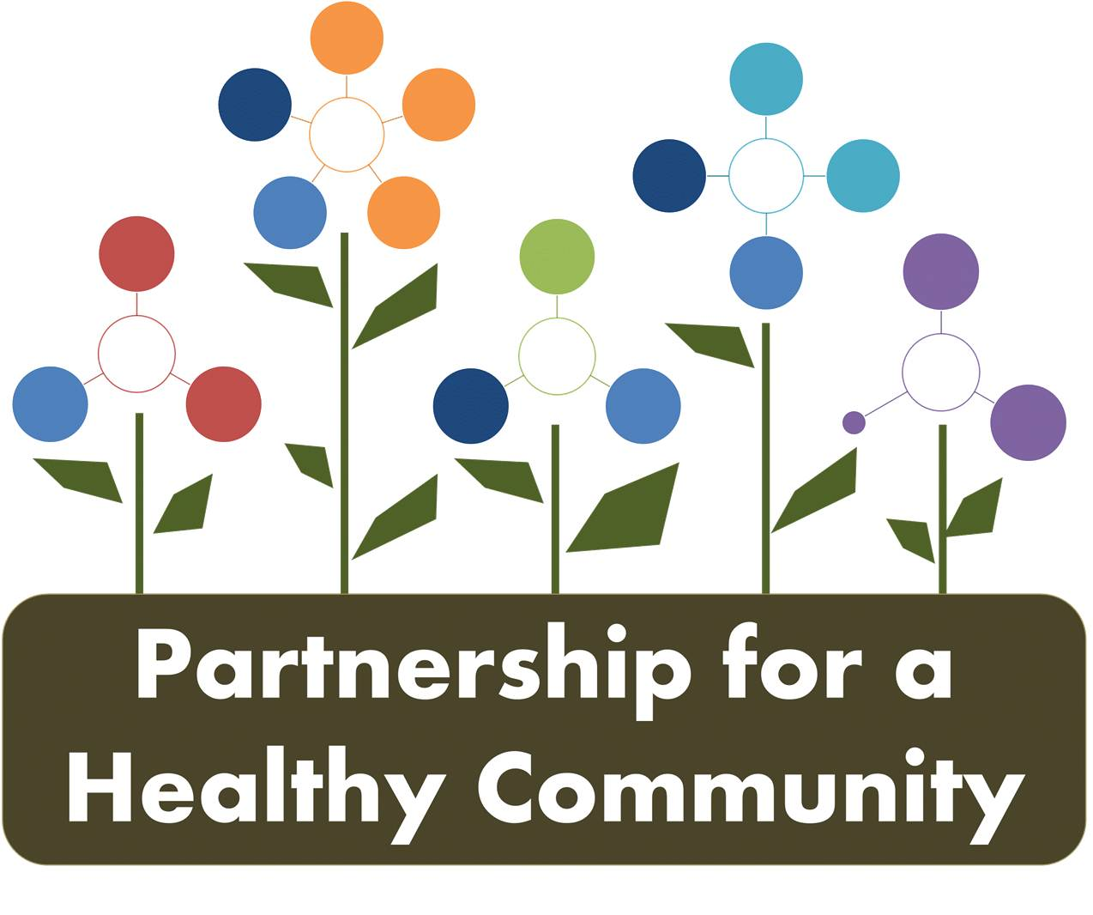
Breast and Lung Cancer Committees-Quarterly Meeting
September 18, 2018
In Attendance:
Greg Eberle-Breast Cancer Sub-Committee Chair, Hopedale Wellness Center/Medical Complex
Ev Neavear-Lung Cancer Sub-Committee Chair, Tazewell County Health Department
Melissa Goetze, Tazewell County Health Department
Julie Angle, Tazewell County Health Department
Jason Haupt, U of I Extension Fulton, Mason, Peoria and Tazewell Counties
Jim Emanuels, Peoria Radon
Wendy Lewis, CRC Life
Diane Hahn, CRC Life
Diana Scott, Peoria City/County Health Department
Michele Sharping, Tazewell County Health Department
Kim Gudzinskas, Tazewell County Health Department
Julie Herzog, Tazewell County Health Department
Donna Long, Unity Point
Catalina Zavata, Peoria Friendship House
Jessica Johnson, Hult Center for Health Living
Andrea Ingwersen, Woodford County Health Department
Nicole Willenborg, OSF (call in)

The meeting was the quarterly meeting and was devoted to breast cancer and lung cancer (Tobacco and Radon).
Lung Cancer Committee Updates (Ev Neavear Chair):
Radon: Ev reviewed the past year highlights of the committee work, including Jim Emmanuel joining the Radon committee and the joint messaging for January 2018, radon actin month.
-discussed the IEMA radon grant RFP, which TCHD has written as an agency in previous years. Ev hopes to write for tri-county area for FY’19 (3 year grant) to include PCCHD and WCHD; grant usually starts in October but still waiting for RFP to become available.
-Unity Point/TCHD is promoting smoking cessation classes/education and radon education at upcoming health fair.
-Jim reported to the group that he is participating in events at Menards and providing radon testing education. He provided an overview of the Radon Awareness Act to the group and discussion ensued about the need for physicians to educate patients on the importance of radon testing. Jim will be attending the International Radon Symposium and will bring back information from that event.
Jason suggested in the next year, part of the committee goals would be to approach area realtors, and increase education/knowledge of realtors about importance of radon testing and the dangers of radon.
Jim reported that although home testing rates have increased, realtors seem to be more on the transaction, not educating on health dangers of radon.
-Discussion took place about inviting a relator to committee meetings or creating a statement/ public awareness piece to reach PAR (Peoria Area Realtors). Additional suggestions about new members included business/restaurant owners, as well as American Lung Association to lung cancer meetings. *The lung cancer committee can discuss this activity further at the next meeting
Tobacco: Julie Angle discussed TCHD efforts for Illinois Tobacco Free Communities (ITFC) for FY18, focusing on smoke-free multi-unit housing and social norms campaign.
Diana Scott shared with the group that for FY19, the tri-county HD’s are writing for the Illinois Tobacco Free Communities grant regionally; that is an option from IDPH and each HD, as well as the region would receive more grant dollars. Efforts will be streamlined for Peoria, Tazewell and Woodford, including contracting with sheriffs’ offices in each county to do compliance (currently PCSO does Peoria, while TCHD and WCHD do compliance for their counties), and the benefits of having law enforcement be responsible for tobacco compliance and complaints.
-The ITFC FY’19 regional grant requires a coalition, which is already formed through Partnership for Healthy Community (this committee), and will be focusing grant strategies/activities surrounding smoke-free housing, campuses and outdoor space (businesses, parks, etc.).
-Jessica shared with the group that Hult received a grant from American Lung Association to support HUD housing requirements to be smoke-free, specifically focusing on residents that also have mental health diagnosis, providing incentives and outreach education for those properties/residents.
-Discussion took place about Smoke-Free Illinois Act for business owners, and clarification about e-cigarettes, vaping and home-rule vs non-home rule communities. Ex: The city of Washington, because of population size, passed an ordinance that specifically included language about e-cigarettes, which is stricter than SFIA. Communities, if large enough, can pass their own ordnance that can be stricter, but not less stringent that SFIA.
-Julie Herzog (TCHD)-explained role of AOK Birth to Five Network and 2 year community assessment regarding smoking rates with women enrolled in WIC; rate of smoking was high. AOK is focusing on decreasing that rate, and referring to Illinois Tobacco Quitline through WIC, dental center and home visiting programs.
Breast Cancer Committee Updates (Greg Eberle Chair):
October is-Breast Cancer Awareness Month; Committee Members reported on upcoming events-
-IBCCP-National Mammogram Day, October 17th. Free walk-in mammogram evets at Unity Point Pekin, 9:00-4:00 and for the first time this year also at: Unity Point-Proctor, Diagnostic Center and N. Allen Road locations. Promotion targeted at women 40-64, never been screened or haven’t been screened regularly.
IBCCP staff will be at each location, enrolling women in the program if they qualify (no insurance, under insured). Kim will get fliers to everyone to help promotion as soon as they are completed.
-Komen, working with Central District of Baptist Churches to promote Circle of promise and hosting a breast cancer symposium featuring speaker Dr. Danny Welch.
-Komen is also prompting Pink Sunday events and the Dream Center is hosting a “Lunch and Learn.”
Discussion took place regarding how awareness is tracked and measured, and how data is complied, specifically in Cornerstone. Outreach and barriers to services is currently tracked for funders, by specific grant (IBCCP, Komen). *Breast Cancer committee can discuss this further at next committee meeting
Greg provided updates from the Partnership Board, and discussed structure moving forward. How can the board support initiatives and committees? Ex: Partnership Board created MOU so OSF would share data with breast cancer committee.
Suggestions included: Marketing-bringing in more community members to comities and educating the community about “what we do.”
-Assign specific person(s) for advertising, website and social media, not relying on HD PIOs only. Discussion took place about promoting Healthy HOI Facebook page, and committee members promoting it personally and professionally. (see tips from Jason Haupt after minutes)
-Proclamation or statement to providers (breast cancer screenings, radon testing, etc.)
-structure and guidelines given to committees form the board about measurable strategies, activities/goals and timelines for meeting structure, chair responsibilities, etc. Committees need to make sure they are not duplicating work.
-Greg updated the group on CHNA timeline, and that moving forward, there will be a data committee that is part of the partnership Board then committees surrounding priorities.
-CHNA data, and secondary data analysis will then be presented in spring 2019, and priorities will again be chosen. Data driven, as before, a new implementation plan will be created, and start in January of 202.
-This is the first time, all health care systems and HDs collected the same data, molded after Mclean and Vermillion counties.
-If cancer (Breast and Lung) is not part of the 2020 prioritization, the Partnership Board, administrators and committee members agreed that work needs to continue (grants, data collection).
-Greg reminded the group to make sure, when reviewing strategies and objectives on dashboards, that it is measureable.
* please “Like” Healthy HOI Facebook page!
Breast Cancer: Tuesday, October 9th, 2018 1:00-2:30 @ TCHD
Lung Cancer: Wednesday October 10th, 2018 1:30-3:00 @ PCCHD

Social Media Management Tips from Jason Haupt-
- Increase Reach
  - All members of working groups need to like, share, and follow the page.
  - Invite friends to join the group.
  - All County Health Dept. pages should have a link out to page and Like and share the page
  - All partner organizations should like and share the page
  - Each County Health Dept. should promote the page at least 1 time per month. Could be a simple “Find more info on how the Heart of Illinois is working to combat high impact health issues for Illinois residents. https://www.facebook.com/healthyhoi/”
- Increase Views
  - All posts should be shared and liked by all members of working groups
  - All posts should be liked and shared by all county health departments
  - All posts should be liked and shared by all partner organizations
  - Use other social media platforms to promote the page. Twitter, Instagram, etc.
  - Find eye catching graphics to share. Infographics are a great tool to use for this kind of page.
  - Promote the Page Inexpensive and has potential to have huge benefits.

