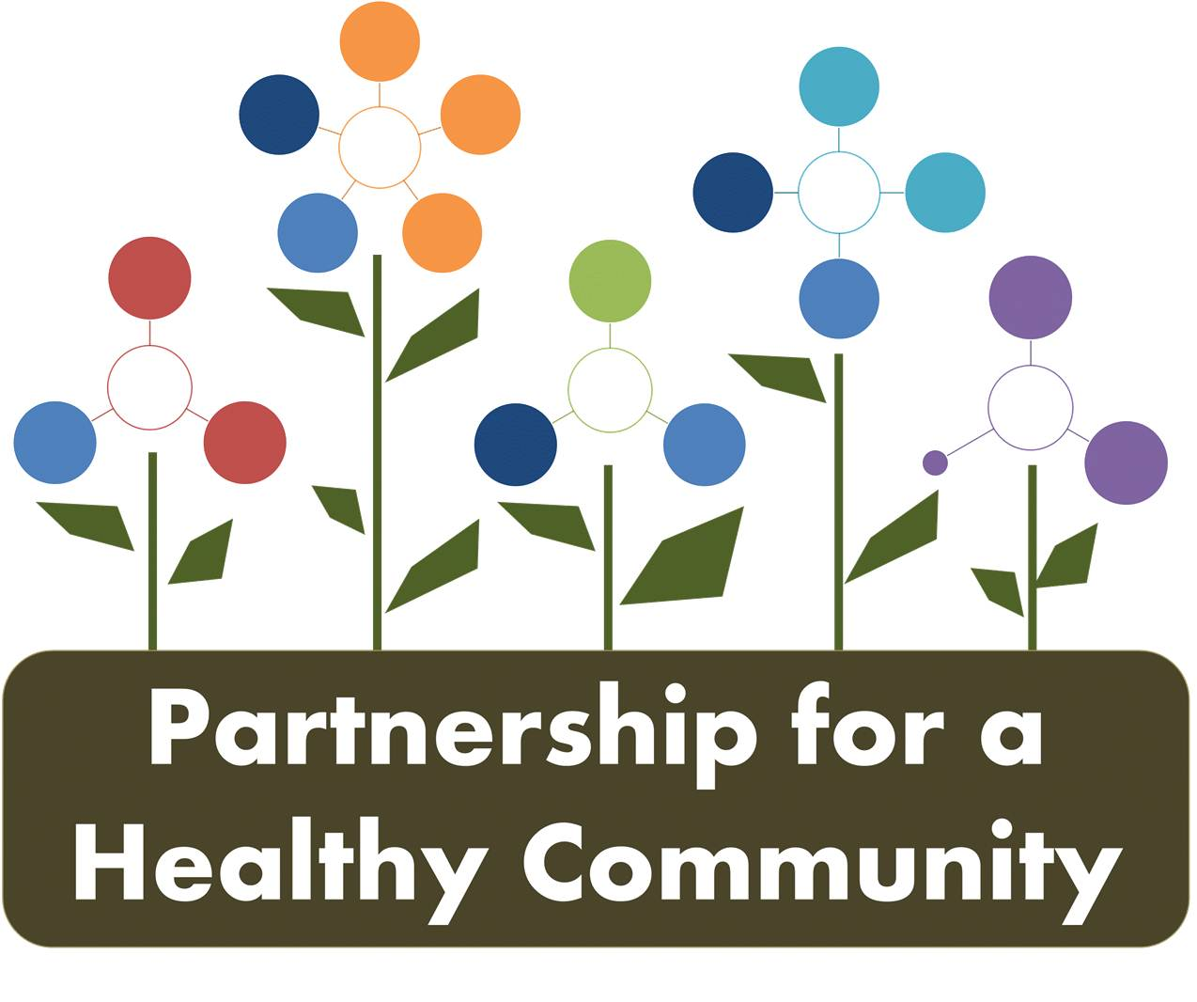
Healthy Eating Active Living (HEAL) Implementation Team
March 9, 2017
Attendees: Adrienne Southerland, Shanita Wallace, Julie Angle, Erin Stout, Stephanie Wurmnest, Michelle McCormick, Kathy Simpson, Morgan Casey, Kaitlyn Streitmatter, Amy Fox, Beth Beachy, Blair Gorsuch, Sharon Mills, John Bouppha
The meeting was called to order at 2:00 pm. The group was welcomed to the team and introductions were made.
Kaitlyn and Adrienne (team co-chairs) reviewed the goals, objectives and strategies of the group as outlined in the Tri-County Community Health Improvement Plan. Strategies and the action steps to implement those strategies are the next important steps for this committee. Today’s meeting focused on the physical activity pieces and next month will focus on the nutrition strategies. Kaitlyn discussed we want evidence based strategies and asked that people who need more information can consult healthypeople.gov or thecommunityguide.org
Adrienne led the brainstorming session.
Strategy- Creating enhanced access to places for physical activity. Places to walk in and outdoors were discussed. Specifically listed were:
- Pekin Dragon Dome- daily 8:30 to 10 am for free
- Parkside Athletics in Pekin- free walking around tennis court area
- Northwoods Mall
- Woodford County Outside Trails near Eureka Lake
- Eureka College gym
- Eastside Center
- Walking Train around Proctor Hospital
- Pekin Park District Trails
- Trails in East Peoria and Morton along old railroad line
- School tracks
- RiverPlex
- Big Box Stores
- Churches with gymnasiums
- East Bluff Community Center
- Franciscan Center
- Lakeview
Cost and access were discussed. The program called Silver Sneakers was discussed as a potential resource to find an area map of walking opportunities. Discussion with Tazewell County GIS to see if a map could be created.
How would we promote a walking program? Discussion of challenge to marketing students in colleges and high schools to assist. Amy and Hillary to discuss and brainstorm ideas with Sharon on this issue.

TCHD offered an intern this coming summer to work on a map and resource if no other resource is located.

Strategy- other Behavior and Social Approaches
“Buddy” or support systems for those making lifestyle changes were discussed. Weight Watchers, WiseWomen, and Silver Sneakers- cost is a potential barrier and when resources are available they may not be for all Counties or are for specific income or insurance levels.

Strategy- Campaigns and Informational Approaches
- Day of Play
- Fuel up to Play 60
- Taking the Stairs
- Walking Programs
- Workplace Wellness Challenges
- Decreasing Screen Time
- Feedback in PE-East Peoria Central Jr High has a great example with a school based program that gives each student heart rate info and it is correlated to their grade

Another idea was to work with Physical Education Teachers to get them behind some of the initiatives a at their institute of training days.

Strategy- other Environmental and Policy Approaches
- Safe Streets to School- Children’s Hospital has a program- Michelle from PCCHD to check on this resource.
- Walkable neighborhoods- May be a land use or policy issue, neighborhood design

A discussion was held on who was missing from our table.
- Park and Rec Associations- Shanita and Stephanie to ask contacts for potential members
- Boys and Girls Clubs
- YM and YWCA’s
- Area Agency on Aging
- Miller Center
- Church membership= Pekin Outreach Initiative- Adrienne was checking with a contact
- Peoria Ministerial Assoc.- Kathy was checking with a contact
- Will reach out to Bryan Miller for Woodford County Ministers- Amy to do at Partnership Board Meeting

NEXT MEETING will be over Strategies for Healthy Eating for Youth and Adults

April 13th at 2 p.m.
Peoria County U of I Extension Office

Other input from members unable to attend

I was reviewing your meeting minutes and saw your strategies for encouraging walking. I was reminded of the previous effort here sponsored by PALM—the Moon Walk -- last held in 2010. See the following link that described the effort—it is the only one I can find that provides some specifics. http://www.meetup.com/Peoria-Singles/events/13101444 It was held for a few years and was a successful effort.
Jim Runyun
one perspective the group might consider is where they can target a large group of individuals and engage them in nontraditional activities. The target group is the business community and you might be able to solicit the involvement of either the economic development groups or chamber of commerce to accept and print contribution to their regular newsletter related to health. Could be the 'health idea' of the month --> what can folks do IN THEIR WORKPLACE to positively contribute toward their health? At one of our meetings in the past one of the public health department indicated they had removed all computer printers from staff offices to force them to get up occasionally to retrieve their printed work and provide for some walking. There was also the idea of staff emptying their own garbage to encourage body movement at work. We did a healthy choices contest here at work recently and one submission was the staff indicated they are doing more standing at work indicating "sitting is the new smoking". There are probably numerous nontraditional activities that individuals in the work place can casually incorporate if they were exposed to them. Just a thought.............. Hope my schedule will allow me to join the group the next time. Thanks.

Mike Kennedy

CONTACT US
Phone:
217-726-9808
Mailing:
Girls on the Run of Central Illinois
907 Clocktower Drive
Springfield, IL 62704
Email:
director@gotrcentralillinois.org

Kathie Brown

