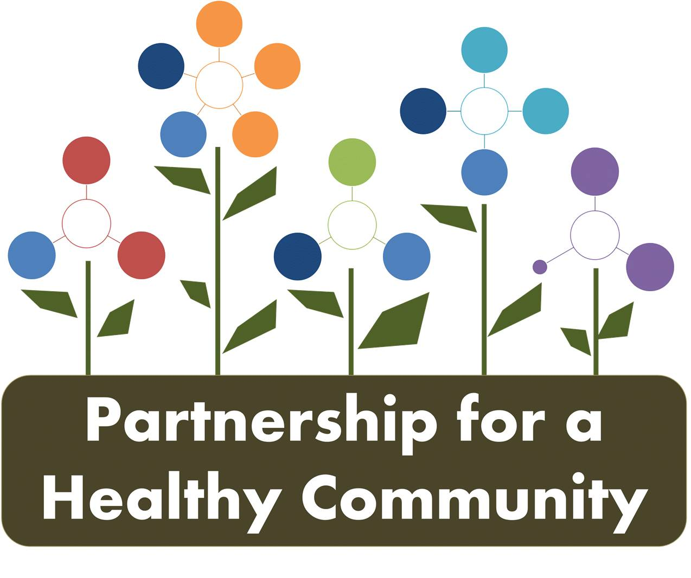
Healthy Eating Active Living (HEAL) Implementation Team
May 11, 2017
Attendees: Julie Angle, Amy Fox, Greg Eberle, Hillary Aggertt, Erin Stout, Cameron Bettin, Jenna Schroeder, Morgan Casey, Michelle McCormick, Sharon Mills, Curt Fenton, Nancy Hinnen, Blair Gorsuch
The meeting was called to order at 2:00 pm. The group was welcomed by Kaitlyn and introductions were made.
Kaitlyn S. reviewed work completed to date with the HEAL committee members. Today’s meeting focused on building action plans around the Nutrition Strategies. Kaitlyn asked the preference of the group to work as one large team or to divide. The group decided to divide into a youth nutrition group and an adult nutrition group to work on filling out a work plan template. Work was completed in the strategies for Adults in: Interventions in Community Settings, Access to Fresh Fruits and Vegetables, and Polices and for Youth in : the WIC or Women, Infants and Children program.
Kaitlyn led the brainstorming session.
A recap was completed when the groups came back together close to the end of the meeting. Next month work will continue on Youth Nutrition and Adult and Youth Physical Activity.

Member Updates: The AHEC has a worksite wellness certification program. Contact Sharon Mills for more info.

Next Meeting will be June 8th at U of I Extension Office in Peoria.

